Monday | Tuesday | Wednesday | Thursday | Friday
A Taste of Italy  Roast Pepper Pizza  Marguerite Pizza  Tomato & Cheese Pasta Pot  Garlic Bread | Tortilla Tuesday  Soy & Ginger Chicken & Rice Wrap  Naked Bean Burrito  Chunky Beef Chilli & Rice Pot | Burger Bar  Beef Burger with Ketchup  Flat Mushroom & Feta Burger  Potato Wedges Pot | Sub Sandwich Central  Chicken Sate Sub Roll  Tuna Melt Panini  Cheese & Tomato Panini | Fish & Chip Friday  Fish & Chips  Vegetable Curry with Rice  Sausage & Chips
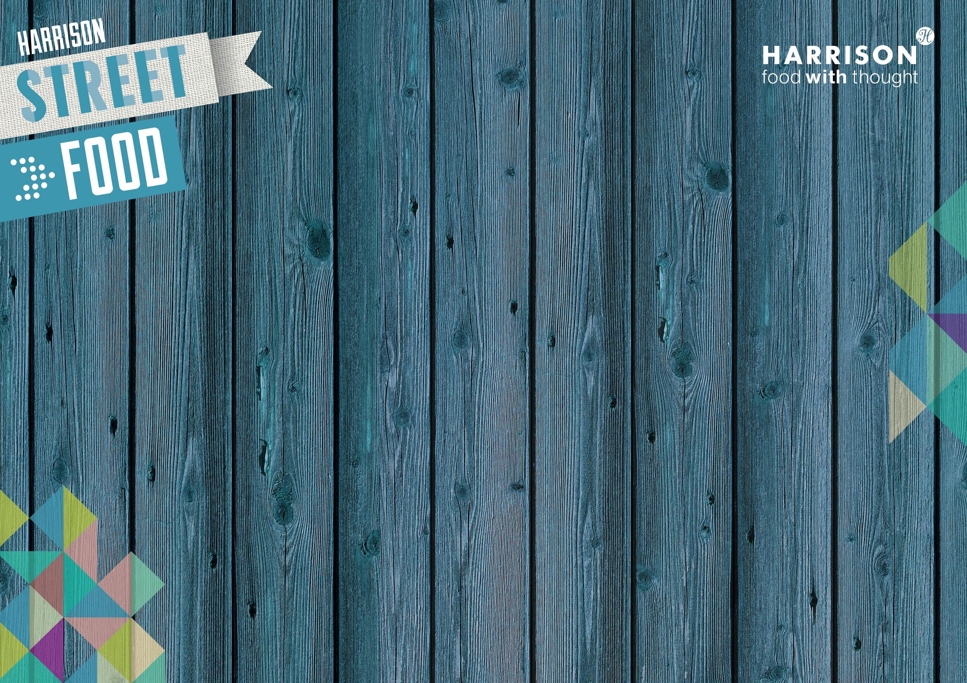
Street Food at the Pod
Week 3

