Monday | Tuesday | Wednesday | Thursday | Friday
A Taste of Italy  Red Onion & Sweetcorn Pizza  Marguerite Pizza  Tomato & Cheese Pasta | Tortilla Tuesday  Chilli Beef Burrito  Roast Vegetable Enchilada  Ham, Cheese & Tomato Quesadilla | Burger Bar  Spicy Chicken Burger  Double Quorn Burger with Mayonnaise  Potato Wedges Scoop | Sub Sandwich Central  Pork Meatball & Cheese Marinara Sub  Tomato & Cheese Panini  Piri-Piri Chicken Wings with Sweet Potato Wedges | Fish & Chip Friday  Battered Fish & Chips  Vegetable Frittata with Side Salad  Sausage & Chips
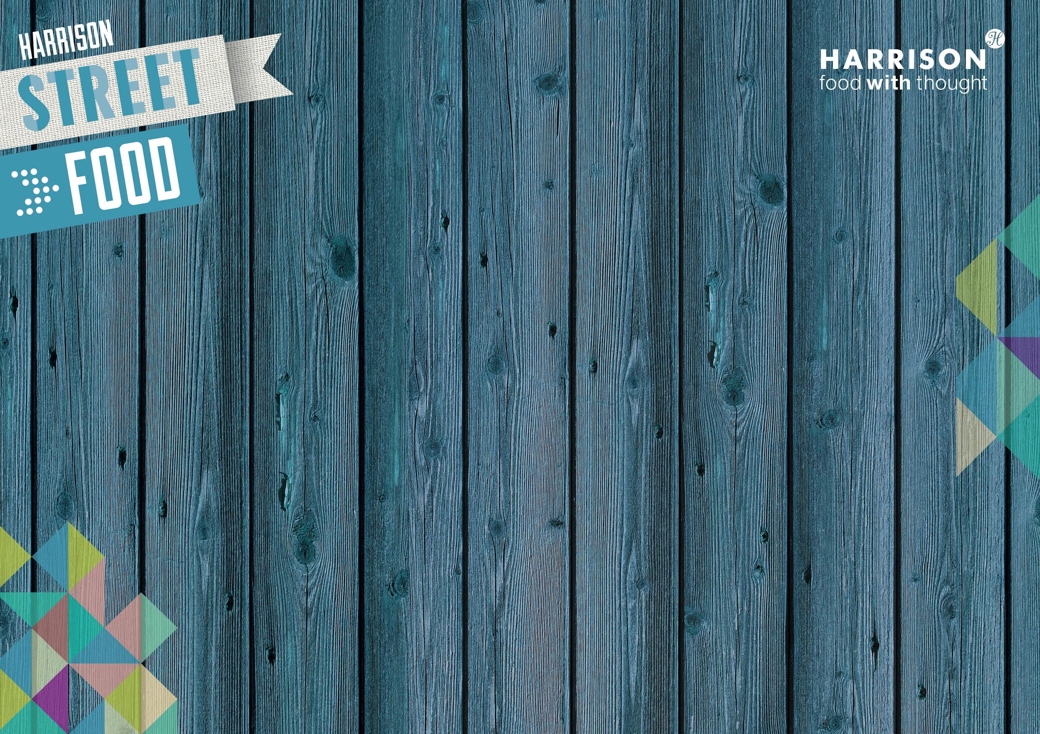
Street Food at the Pod
Week 2

